CIS4930/CIS6930: PROJECT 2

Group #10

Prateek GOYAL, RAMIT SURI, ARVINDH MANI, KRITI SHAW

**TABLE OF CONTENTS**

INTRODUCTION………………………………………………………………………………..**2**

USER RESEARCH……………………………………………………………………………....**3**

BRAINSTORMING PROCESS…………………………………………………………………**4**

USER PERSONAS……………………………………………………………………………....**5**

TASK FLOW DIAGRAM……………………………………………………………………….**9**

WIREFRAMES…………………………………………………………………………………**12**

**Introduction**

Every year twice as many parking decals are sold, as parking spots available. There is no guarantee that a user would get the parking space, as he is not able to see whether parking is available until reaching the destination itself. More than a few users have iterated that they had to go back home after coming to campus, just because there was no spot available.

The UF parking app allows a user to search for parking spots available on campus, right from their homes. It allows users to reserve their spot up to 30 minutes prior to time needed. Have an interview tomorrow? Don’t sweat, we got you covered with the advanced reservation feature. Running late? Reservation extender to the rescue. Adding various features like disabled filter, or making nearby places of interest, the UF parking app increases the immersion and caters to all your parking needs.

**User Research**

General questions regarding parking issues were formulated, and potential users were drafted and put across to the focus group. Some sample questions include:

* How often do you bring your car to campus?
* How long do you usually park the car for?
* How far is the parking spot from the actual destination?
* What are major problems you face during parking?
* Any parking story you would like to share.

The focus group needs to represent the range of users of the app. A total of 8 users formed the focus group, which comprised of a wide scope of user characteristics. Some of these characteristics are:

* Student category: Undergrad/Grad/PhD
* Frequency with which cars are brought to campus: Everyday/thrice a week/less
* Likelihood of downloading the app: Rated on a scale of 1 to 5
* Age group: Most students belong to group 18-25

Users were probed about problems related to parking which they faced regularly. Their responses were documented and used to finalize the app design. Users were also asked to provide interesting anecdotes, which may or may not be related to these problems. The story could have been any instance which stood out, not necessarily good or bad. Below are the responses:

|  |  |
| --- | --- |
| User1 | Since I am a new student, I don’t always find a parking spot close to my destination. The places I park the car are usually far, and I often have to walk for over 15 minutes. |
| User2 | I would like a way to view empty parking lots on campus, but I’m quite lazy when it comes to using apps. I don’t like to repeatedly feed data to apps. A parking story which I remember was when I had parked my car at the parking lot, and was over at Marston studying the entire day. When I left, I found that my car had been towed. I had no clue who to contact to get the car back. |
| User3 | A few months ago, I had an important interview scheduled for the day. I reached the location on time, but could not find a parking spot. I spent a fair amount of time looking for a spot, and I ended up getting late for the interview. I wish there was a way to book a place in advance. |
| User4 | On Tuesdays and Thursdays, I have committee meetings in addition to my classes and part-time job. It requires me to take my car out several times and I lose a lot of time trying to find the parking spot. What I would give for an easy way out of this problem… |
| User5 | I have my classes at either Weil Hall or the CISE building. The closest parking spot is probably next to Tebow, but there is no way to know whether it’s vacant or not. When it’s full, I often have to drive back to Reitz. I end up getting late more often than not. |
| User6 | It would be nice to have some sort of guarantee of a parking spot. Just an assurance that I won’t have to run around looking for a place, all the while worrying that I’m getting late for class. |
| User7 | I don’t have a problem with the existing parking process. Sure, I might have to put my car someplace far away but then I can always do a little walking. I find the idea to have an app for parking to be somewhat ludicrous, unless it has some kickass features associated. |

**Brainstorming Process**

Based on the above responses, and responses to other questions asked to the focus group, user needs were identified and prioritized. Moving forward, these needs would drive the final application design. The needs were identified as follows:

* Ability to look at available parking spots
* Ability to reserve a parking spot (while driving or in advance)
* Ability to reserve multiple parking spots
* Ability to extend reservation

Apart from the above stated user needs, the application needed a few “kickass” features which would augment the existing abilities. Some such needs were identified to be:

* Ability to learn from a person’s usage pattern
* Ability to provide information apart from the bare necessities

Based on the above needs, the following features were brainstormed:

* *Spot reservation* – user is able to reserve parking spots
* *Paid reservation* – user can only reserve a parking spot by paying for it
  + Rejected because students already pay for parking decals
* *Advance spot reservation* – user is able to book a spot in advance
* *Multiple spot reservation* – user is able to book multiple spots on the same day at once
* *Extension of spot reservation* – user can extend his parking spot for an additional period of time
* *Bulk reservation* – user is able to book parking spots for an extended period of time at once
  + Rejected because it has potential for feature abuse and unethical use
* *Parking spots outside campus* – user can look at parking spots outside campus
  + Rejected because it is outside the scope of the app
* *Standalone navigation feature* – app contains its own navigation feature
  + Rejected due to potential redundancy
* *App learning* – the app smartly finds patterns in user spot reservation

After the brainstorming process, the following app features were finalized:

* *Parking spot reservation (instantaneous & advance)*: A parking spot can be reserved by the user, up to a day in advance. Reservation is subject to availability of the parking spot. Advance parking is subject to payment. Instant reservation can only be done 30 minutes prior to actual time, in order to prevent misuse.
* *Multiple spot reservation & notification*: App allows user to book multiple parking spots in one go. However, only the first spot would be confirmed at the time of reservation. For any subsequent spots, real-time data would be analyzed and, based on availability, a confirmation would be provided. Feature subject to same restrictions. Also, a user gets a notification in both availability and non-availability of parking spot. In the first case, user can choose to confirm the spot. In the second case, user needs to look at alternate parking solutions.
* *Extended reservation*: 30 minutes before the parking reservation ends, user gets a chance to extend their reservation if there is at least 1 regular parking spot available. If there is no parking spot available, no such notification arrives.
* *Set schedule*: If a user follows the same schedule every day, they can set a schedule at the beginning of the week or otherwise, giving the parking location needed and the duration. 30 minutes prior to that time, a notification appears asking for confirmation of the same. This feature is implemented to reduce the amount of data that a user may need to enter (once instead of multiple counts).
* *App learning*: The app, over a period of time, learns the usage patterns and automatically suggests the parking location/time based on those patterns. It basically reduces the entire process to a one-tap mechanism.
* *Bookmarking*: The bookmark feature simply lets you bookmark a location and Users can then access these locations from a bookmark page, thus obviating the need for a search.
* *Assorted features*: Features which increase the app usability such as disabled filter, places of interest, push notifications, ability to look up parking outside campus (in the unlikely event that the entire campus is full), contact information (incl. emergency numbers), etc.

**User Personas**

Based on these user needs, a selection of user personas were formed. The personas intend to reflect the range of target users for the app. The following personas (with their respective stories) were created:

1. **Karen – “I’m as lazy as a bear in hibernation.”**

Karen is a senior-year grad student, doing her Masters in Food Tech. She’s lazy by choice and prefers to work from the comfort of her home. The few days that she decides to show up to college, she prefers to drive. When it comes to apps, her phone is full of one-touch widgets which simplify her work immensely.   
*Scenario #1*

Karen is sitting at an interview for Foogle, her dream company. The first round went on longer than she expected; now she gets a reminder from the app that her reservation is about to end. Since her second round is about to begin, she chooses to extend the reservation. As soon as she gets a confirmation, she pushes it out of her mind and focuses on calming herself before the big interview.  
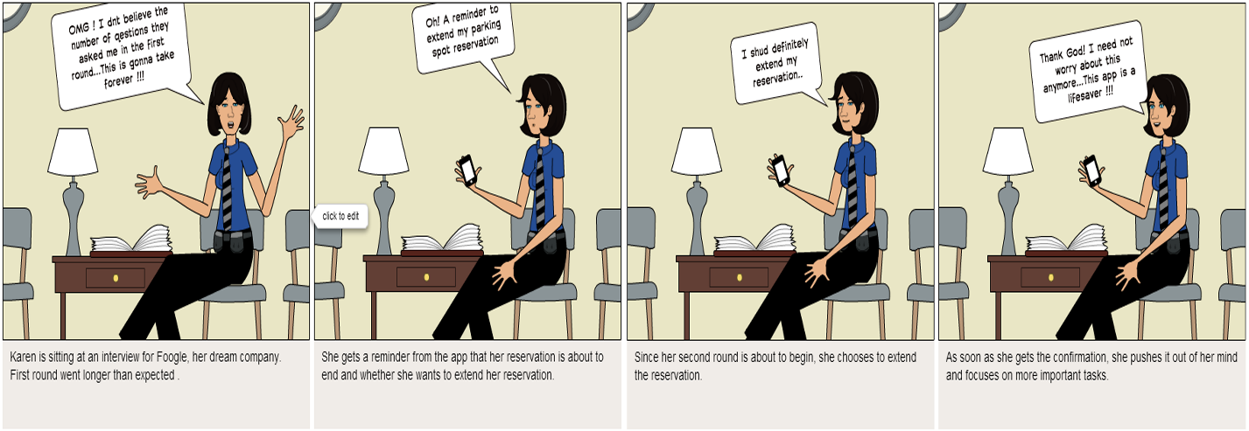

1. **Fred – “I can’t imagine going anywhere without my baby!”**

Fred is an undergrad, who takes his car every day to the university. He just got his own car as a gift from his father and loves to take it everywhere. He is used to spending the whole day at the university, either in class or at the library, and returns home only late at night.

*Scenario #2*

Fred is on his way to class, totally chuffed about his new Mustang and listening to his loud music. He has Java class in the CISE building. At the red light he whips out his phone, opens the app, puts in the final destination and waits for the app to show the nearest available parking spots. He chooses one he likes and follows the directions.

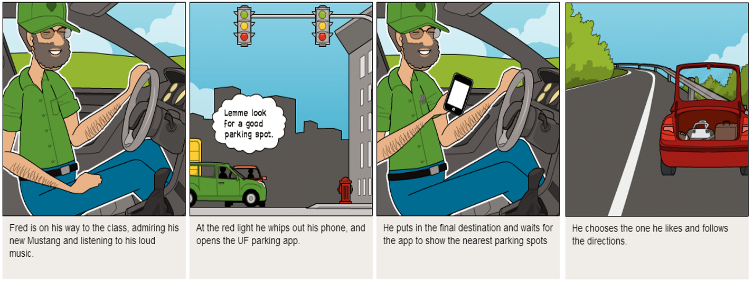

*Scenario #3*

Fred is driving to college, and is late for his midterm exam. He is worried he might not find a good parking space in time. He opens the app, and sees that a spot is available for reservation near to his exam hall. He reserves the spot on the go, and makes it on time!

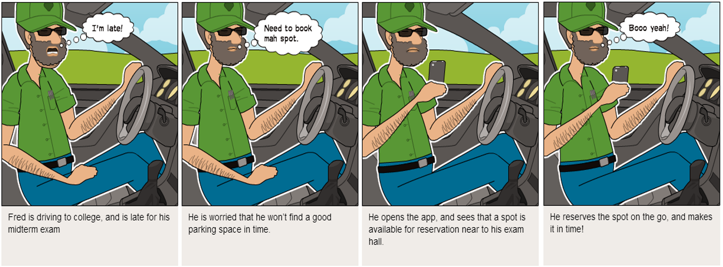

1. **Utkarsh – “Darn it, I’m lost again.”**

Utkarsh is new to Gainesville, pursuing his PhD in Artificial Intelligence. He is unfamiliar with the campus, and often gets lost trying to find the closest parking spot. He loves the idea of the parking app: not only would it save him a lot of time, but it would also inform him of places of interest on campus.

*Scenario #4*

Utkarsh has been preparing for his thesis defense, scheduled for tomorrow. He is confident enough that he can do well: after all, he has spent a lot of time thinking about it. He needs to be on time, as getting late would leave a really bad impression. He opens the app and, using the advanced reservation, makes sure he is not left hanging tomorrow. He sleeps comfortably, knowing he won’t have to waste time on this in the morning!

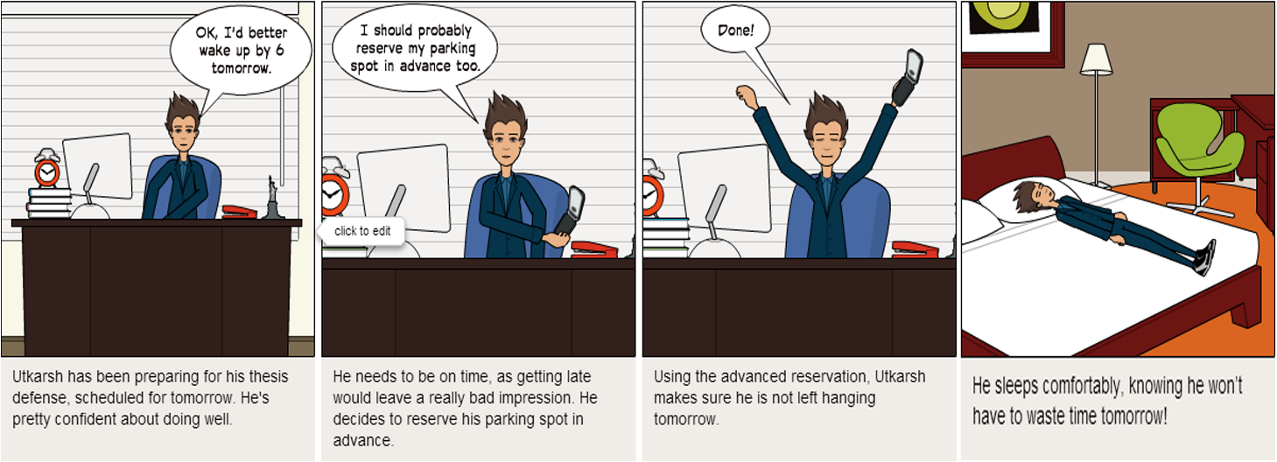

*Scenario #5*

Utkarsh successfully defended his thesis, and now has a regular schedule to follow. He drives to the university, and loves the parking app which has helped him identify various points of interest around campus. But he doesn’t like to search for a location daily. So, he opens the “Set Schedule” page and fills his requirements. The app then searches for a location at the designated time, and asks Utkarsh for a confirmation.

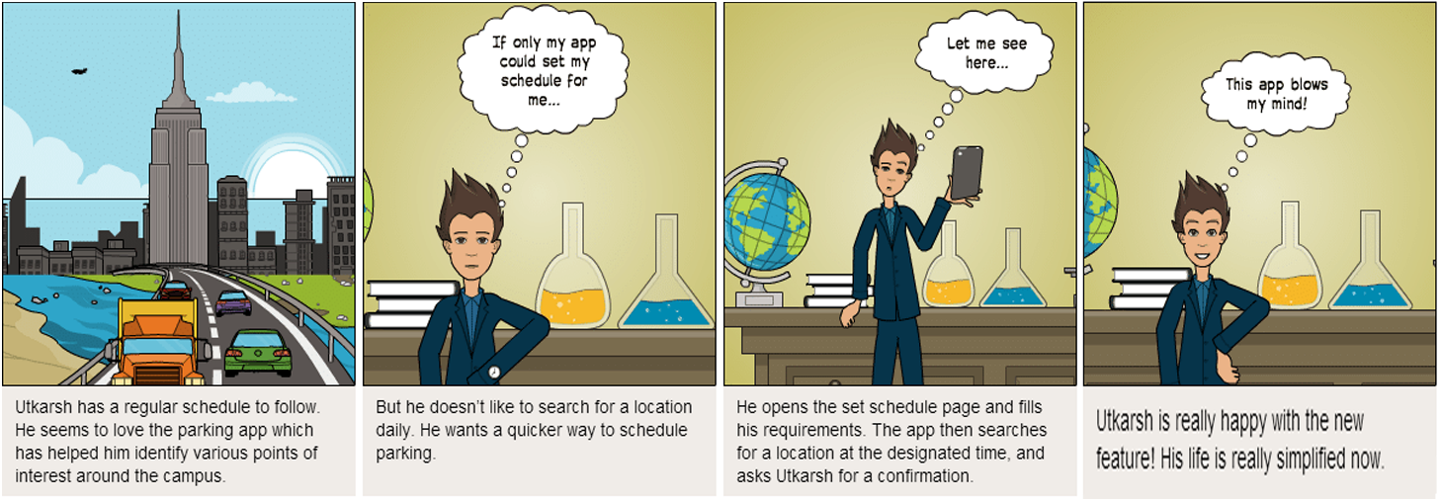

1. **Cathy – “OMG! I’m actually on time for once.”**

Cathy is a freshman grad student, doing her Master’s in Statistics with Computer Science as her minor. She juggles classes, a part-time job and coding club meetings. If she gets any time away from work, she loves to go to Library West and read Sidney Sheldon. She is loving grad life at UF – after all, being a Gator is something to be proud of! It’s just that she doesn’t like that she spends a lot of time trying to find places to park her car.

*Scenario #6*

Cathy opens the parking app, and tries to recall her schedule for the day. She needs to go to locations A/B/C, and they aren’t close enough to walk. She decides to use the “MultiPark” feature to reserve parking for all locations. Entering information into the app, she gets a confirmation for the first location. For once, she’s actually on time for class! Before the second class, she gets a notification that a spot at B has been reserved.

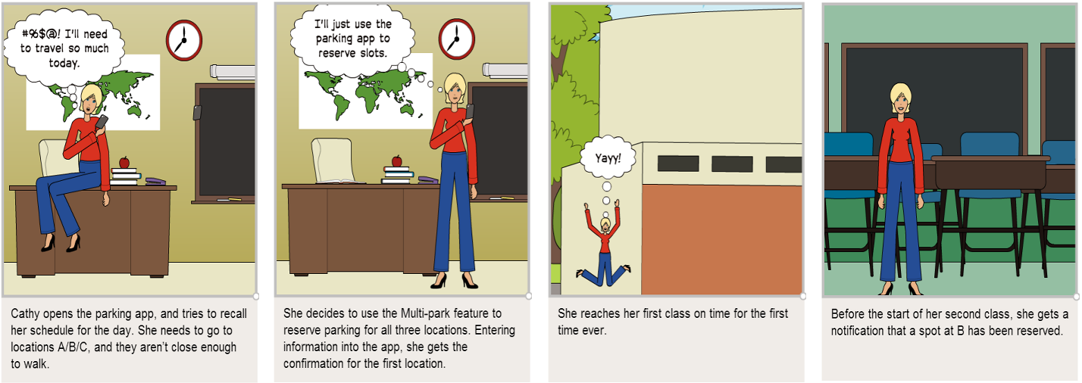

*Scenario #7*

Cathy has been using the app for some time now. She loves that she can bookmark her favorite parking spot, and then directly access it from the Bookmarks page. One morning, she gets an automatic suggestion from the app to reserve a spot at her favorite parking area. Apparently, the app learnt the usage pattern! Now she only needs one tap to book her spot. Happy Cathy!

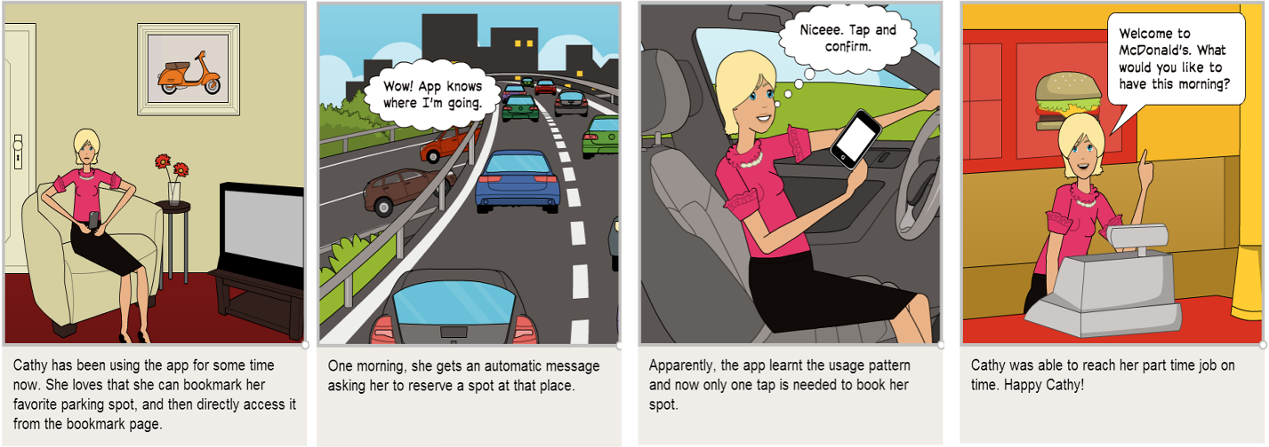

**Task Flow Diagrams  
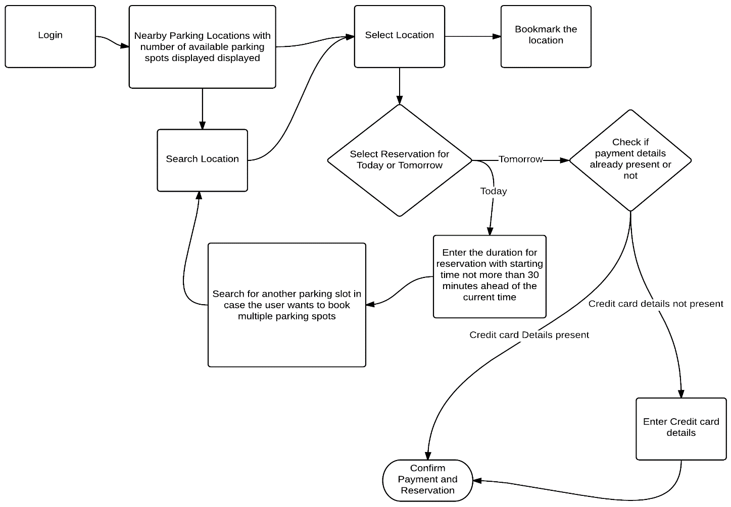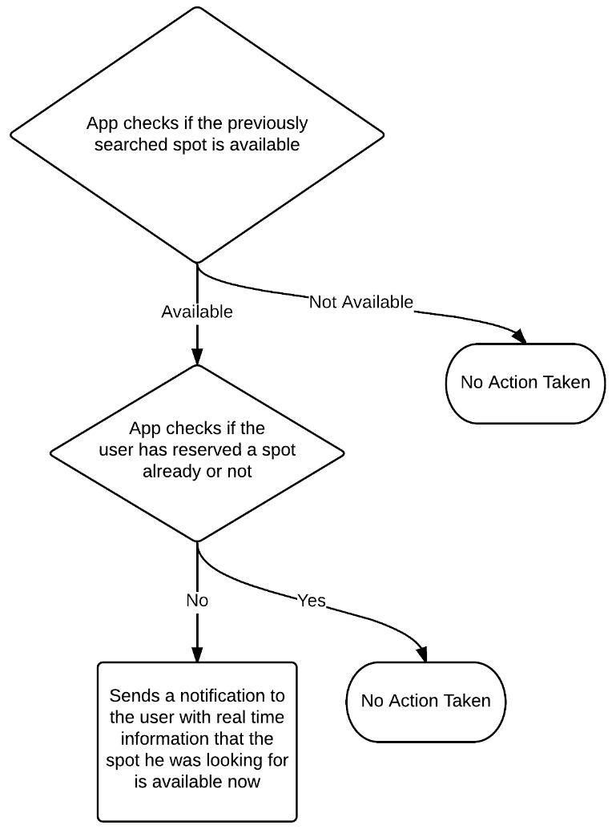**

**Above:** Task flow during general reservation, advance reservation and multiple reservation

**Left:** Task flow for “real-time information” feature

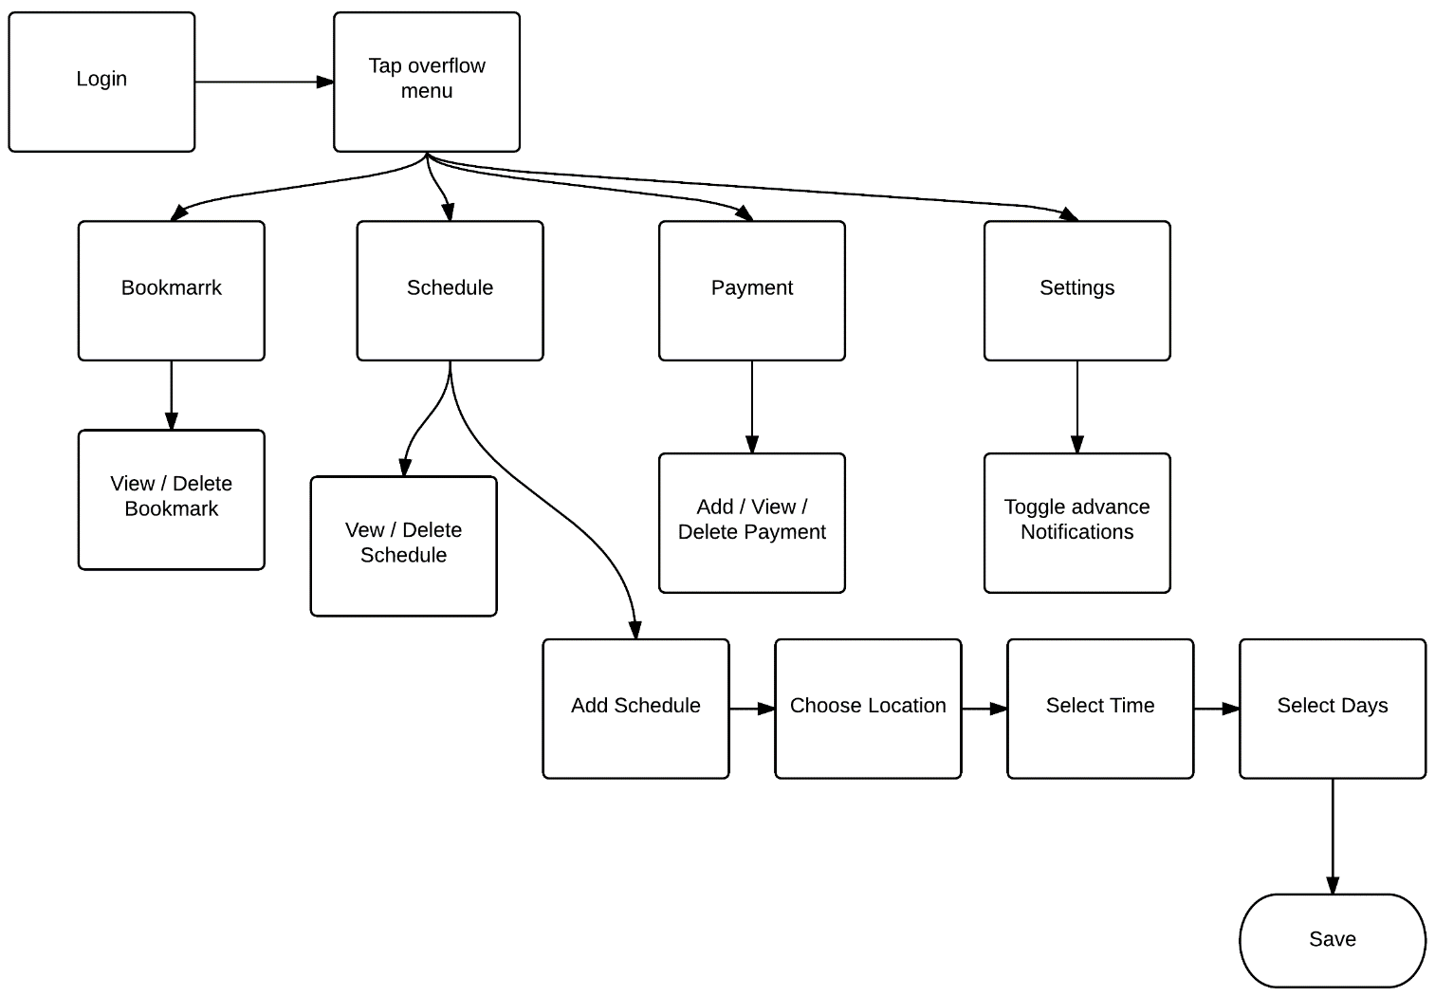

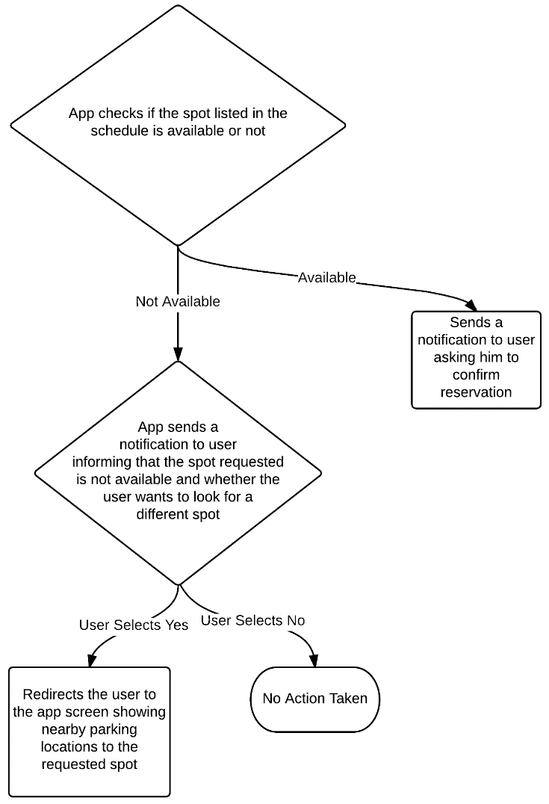

**Above:** Task flow for overflow menu

**Left:** Task flow for “spot availability notification” feature

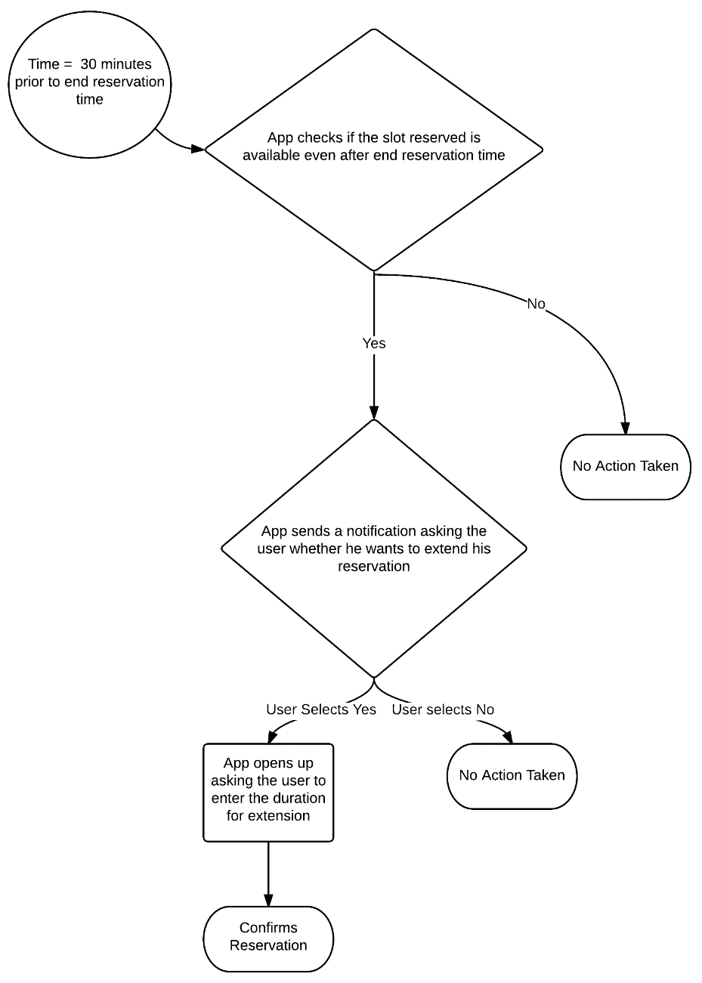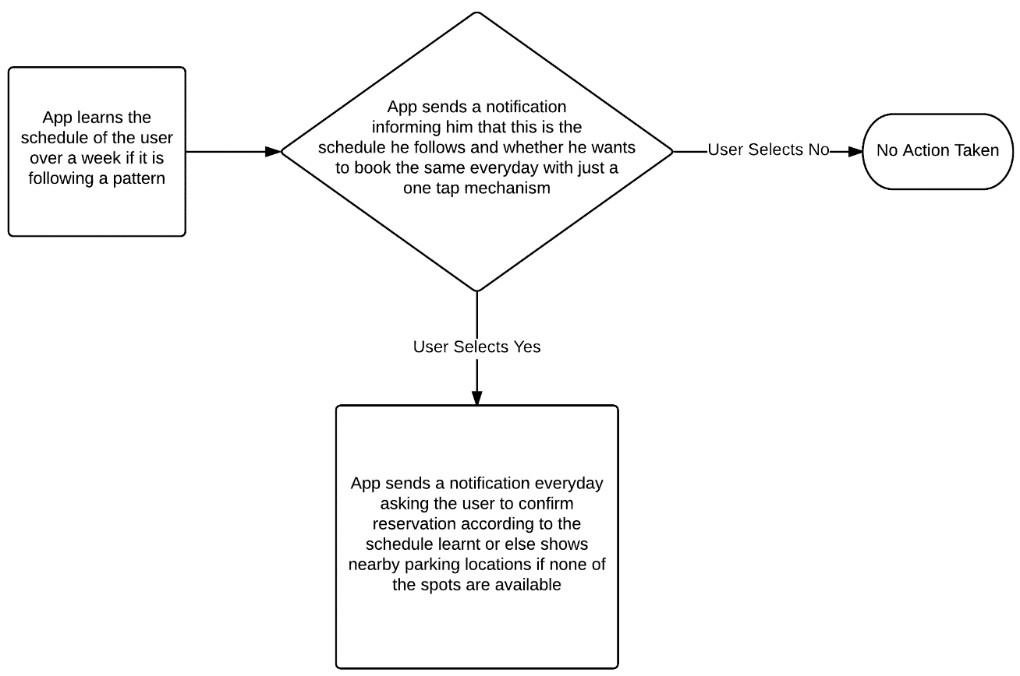

**Above:** Task flow for extension of reservation

**Below:** Task flow for “one-tap notification” feature

**Wireframes**

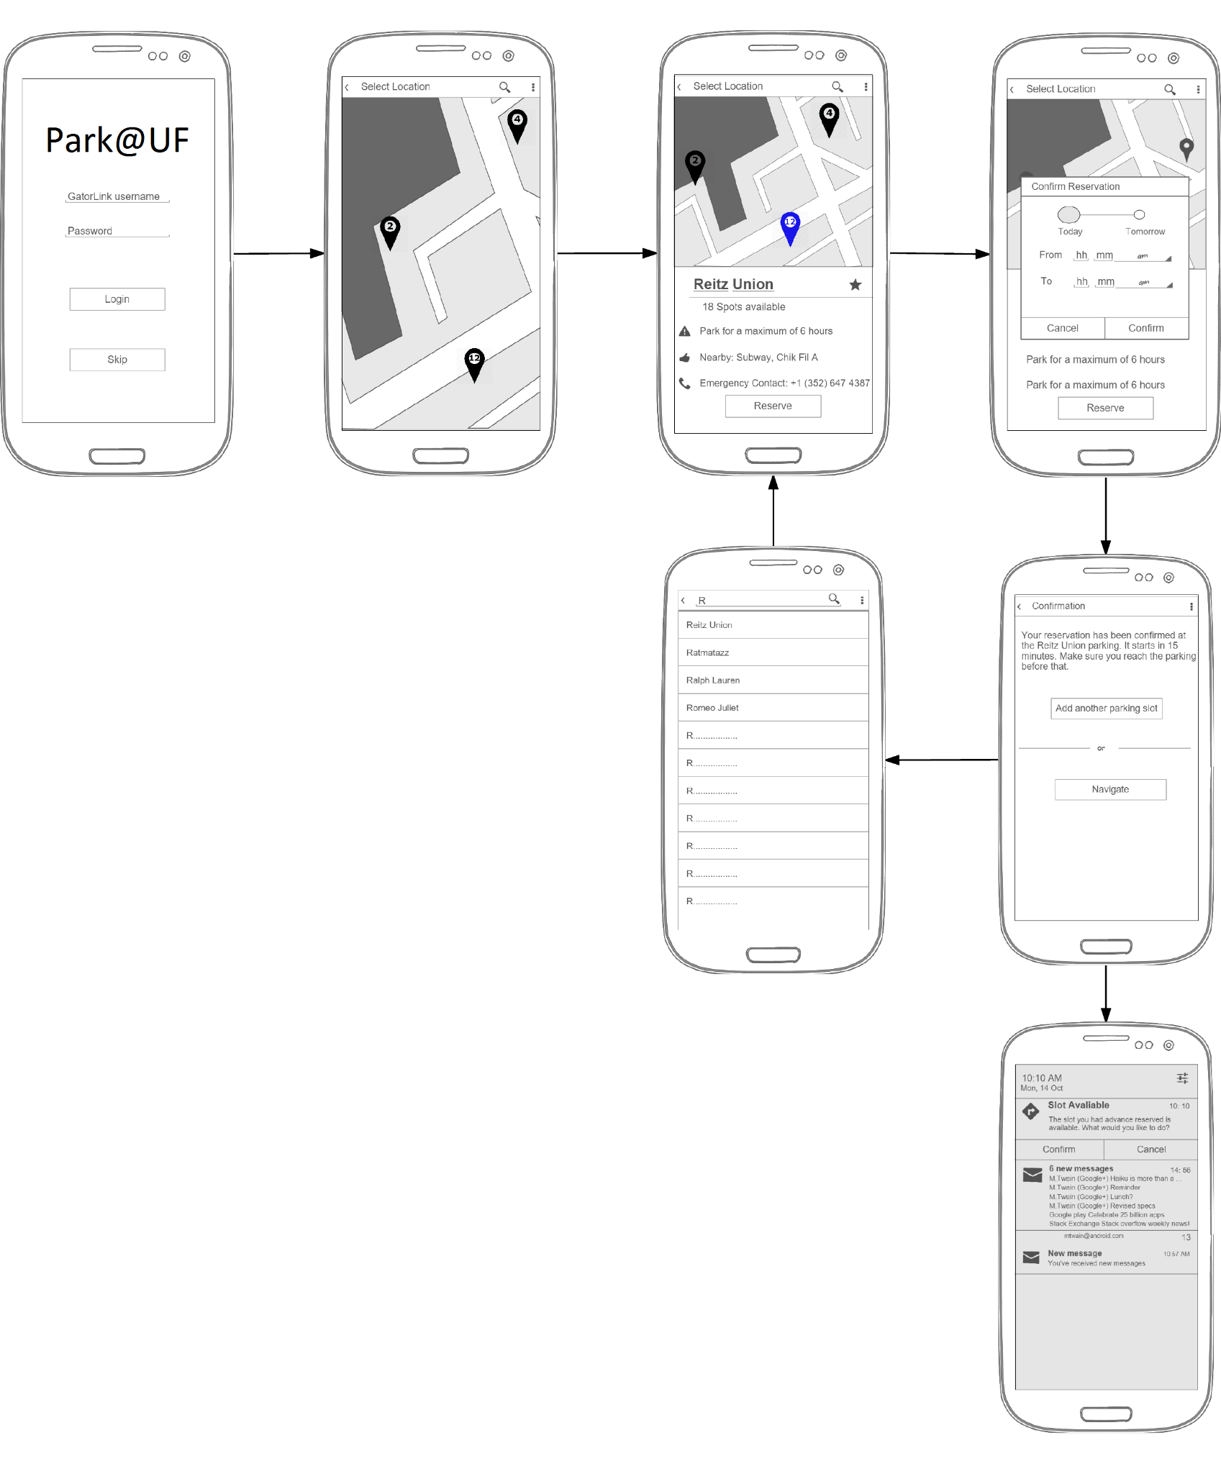

**Notification - Slot Available**

**Location**

**Select**

**Confirmation**

**Search Locations**

**Set Time**

**Nearby Parking Slots**

**Home Screen**

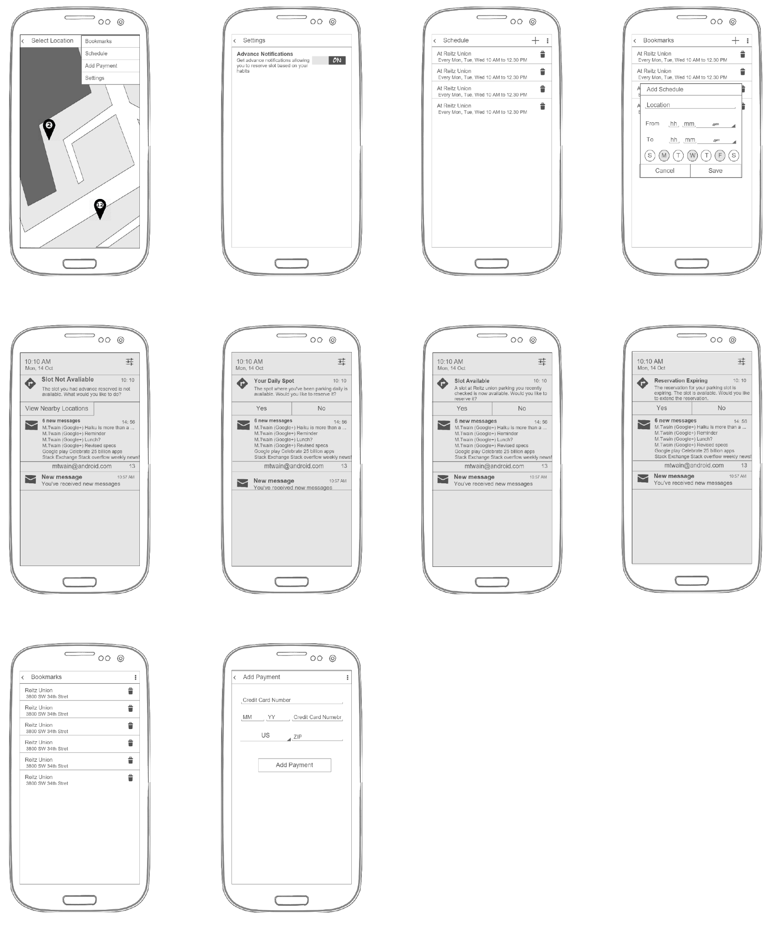

**Notification – Daily Slot**

**Add Payment Method**

**View/Delete Bookmarks**

**Notification – Slot Not Available**

**Notification – Slot Available**

**Notification – Reservation Expiring**

**Add Schedule**

**View/Delete Schedules**

**Settings**

**Overflow Menu**